# Scientific Authorship with the PCORnet Bariatric Study (PBS)

## How can you contribute to scientific manuscripts?



***A*s our study begins to have results to share, the writing process is an exciting step!** But it can be confusing – especially if you are new to scientific manuscripts or writing with large groups. We hope this Q&A will help the PBS team “be on the same page” as we write manuscripts together. We welcome your feedback on this document and the writing process.

### Why does authorship matter?

**Being an author on a scientific manuscript is an important part of research.** It shows that you contributed to the work and implies responsibility and accountability for what is published. It can also be important for professional or academic advancement.

Most scientific manuscripts are written by a group of collaborating researchers. As a stakeholder, you bring a unique perspective to the PBS writing group. You can help us understand how our research may affect different groups with an interest in bariatric surgery. Your experiences also help us figure out how best to get our results out to the people who need them to make better health decisions.

### What makes an author?

The PBS uses criteria from the International Committee of Medical Journal Editors (ICMJE) to define authorship. **To be included as an author, you must meet all four criteria**:

1. You made substantial contributions to the conception or design of the work – or the acquisition, analysis, or interpretation of the data. (Participating in study conference calls fulfills this requirement.)
2. You drafted the manuscript or revised it critically for important intellectual content.
3. You approved the final version to be published.
4. You agree to be accountable for all aspects of the work, including ensuring that questions related to the accuracy or integrity of any part of the work are appropriately investigated and resolved.

### I meet the ICJME criteria. What are the different ways to be an author on a PBS manuscript?

We have 8 scientific manuscripts planned for this study. Each manuscript has two groups of authors. For each manuscript, you will have a chance to be in one of these groups.

**The “byline authors group”** includes the authors who will be listed at the top of the paper when it is published. It is made up of two existing groups:

* The writing group, a small number of PBS team members responsible for writing the initial draft of the manuscript.
* The Scientific Core Team, which leads the effort to plan and carry out PBS analyses.

**The “collaborativeauthors group”** includes the authors who will be listed under the group name “PCORnet Bariatric Consortium.” Even though authors in this group are not listed at the top of the paper, they will still be included as a named author in searchable online databases. Authors in this group will include:

* All Clinical Data Research Network Bariatric Principal Investigators and Executive Stakeholders who were not part of the byline group for that manuscript.
* Individuals that were selected by the CDRNs to represent each of their data contributing sites as collaborative PBS authors.

Here is an example from PubMed, one of the most prominent databases for scientific researchers. You can see how David Arterburn is listed as an author under the manuscript’s “Collaborators” section but not in the byline authors group. He is not explicitly named on the manuscript but he is given authorship credit as a member of the study’s collaborative.

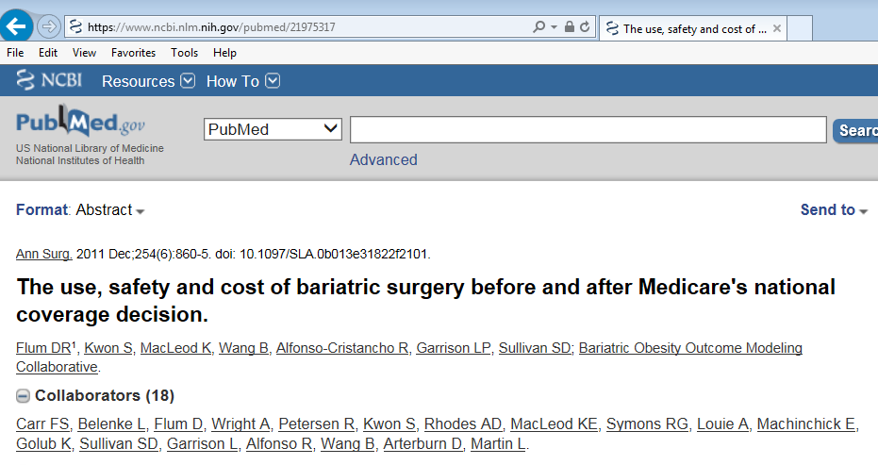

### How is the order of authors determined for PBS papers?

**On most scientific papers, the order of byline authors indicates the relative contributions of each author.** For example, the person who led the writing is usually listed first. The most experienced member of the team is often considered the “senior author” and is listed last. Our goal is to determine the order of authors in an equitable way for all PBS papers.

**Byline author group:** Each member of the PBS Scientific Core, CDRN Bariatric PIs, and Executive Stakeholders has the opportunity to be part of a manuscript writing group. During a study-wide process, writing group members selected their authorship position or were assigned a position for each paper. Scientific Core members chose first, followed by CDRN Bariatric PIs, and then Executive Stakeholders. Scientific Core members will be listed after the 6th author on the paper byline and before the senior author. The order of these Scientific Core members will vary according to their level of contribution on that paper.

**Collaborative authors** will be listed in alphabetical order.

### What if I am invited to be an author, but I would prefer not to be one?

Not everyone is interested in being an author. If you decide it’s not a good fit for you, we would still like to recognize your contributions in the paper’s formal “acknowledgements” section.

### How can I revise a manuscript for important intellectual content?

**First, read through it carefully, with an eye on how to make improvements:**

* Look for factual errors, inconsistencies, areas that lack clarity, or omissions in the text.
* Background information that can help clarify the goals of our papers is also very useful.
* If you know the bariatric literature well, please check to see if key articles were overlooked, and should be added to the introduction or discussion.

**Second, think about how the results could be used to improve health or healthcare:**

* Consider pointing out what the study findings could mean for decision-making on the part of a patient, clinician, payer, health policy maker, or other stakeholders. These observations are typically noted in the discussion section of a manuscript.
* You can also give ideas of how we can tailor findings to different stakeholders.
* A scientific manuscript may not be the best way to present findings to certain stakeholder groups. If this is the case, you can suggest how we can best target those groups (e.g., flyers, social media messaging, and publications in venues other than scientific journals).

**Please do not provide detailed suggestions for alternative wording**. Each paper will have dozens of authors who may suggest edits that conflict with each other. If there is a sentence or a section that does not make sense, please point it out and note why it is confusing or how it could be misinterpreted.



### What to expect when we submit a PBS paper to a journal

*Before the paper is submitted:*

* You may be asked to sign an **authorship contract** which outlines expectations for all authors.
* You will be asked to **review a draft and suggest critical revisions to the lead author.** You can also conclude that the draft looks “fine as is.”
* You will be asked to **approval a final draft in a timely manner**. It will then be submitted to a scientific journal.
* At some point in the process, you will be asked to **complete a statement on your potential conflicts of interest (COI).** Your writing group will share the journal’s COI requirements with you, and the PBS study management team can help if you have questions about any conflicts you may have.

*After the paper is submitted:*

* **The review process may take several months.** The journal editor will consider comments from two or more outside reviewers and then send the lead author a decision. Please keep in mind that it is quite unusual for a paper to be accepted as submitted.
* **If the paper is accepted,** the journal may give the lead author an approximate publication date.
* **If the paper receives an invitation to “revise and resubmit,”** the writing group will need to revise it based on comments from the reviewers. Then all members of the PBS Collaborative and the byline author group will need to approve the revised version before it goes back to the journal for a second review.
* **If the paper is rejected,** try not to get discouraged. It happens all the time in medical publishing. In such cases, the lead author will usually find a different journal where the article may be a better fit. The writing group will then revise the draft and make formatting changes to fit the new journal’s requirements. Again, you will be asked to review and make changes as needed.

### If I suggest edits, will they be incorporated into the paper?

The writing group will consider all suggested edits – but not all suggestions can be incorporated. The manuscript’s lead author must decide which suggestions to act on as they edit the manuscript. He or she considers factors such as the clearest way to make a point and the overall flow of the manuscript. In addition, scientific journals often have very strict word limits. This means papers must be very concise. If you make a suggestion that is not incorporated – or not included exactly as you suggested – please do not be offended. The writing team is trying to balance the input of dozens of authors while meeting strict editorial and formatting guidelines.

### What if I have no edits to suggest?

It is OK if you don’t have edits to suggest before the manuscript is submitted. But you must contact the lead author to confirm that you read the paper carefully and have no revisions to suggest. This shows that you have met ICJME criteria to be an author. If we do not hear back from you, you will not be able to be named as an author.

### Who do I contact with questions?

* Kathleen McTigue ([kmm34@pitt.edu](mailto:kmm34@pitt.edu))
* Karen Coleman ([Karen.J.Coleman@kp.org](mailto:Karen.J.Coleman@kp.org))